# HW8-Scikit-learn Model Serving with Online Prediction Using AI PlatformCopy the username, and then click ****Open Google Console****. The lab spins up resources, and then opens another tab that shows the ****Choose an account**** page

List the active account with -> $ gcloud auth list

List the project ID with -> $ gcloud config list project

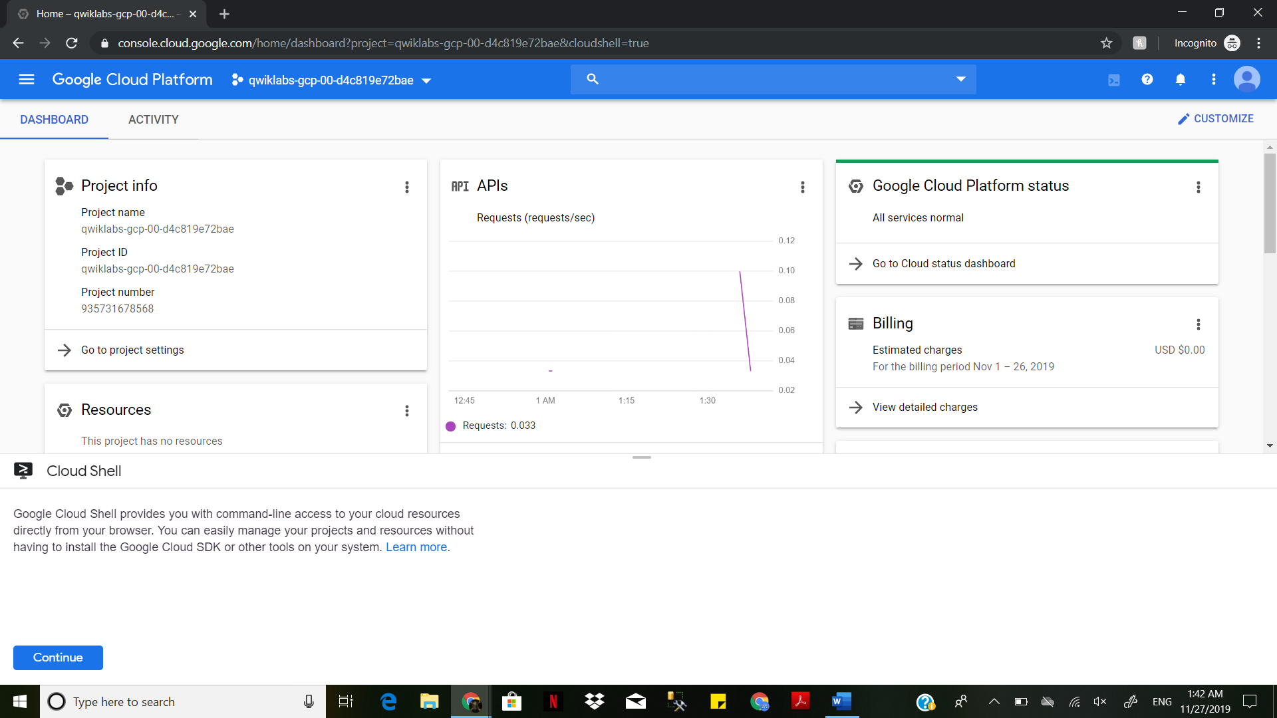

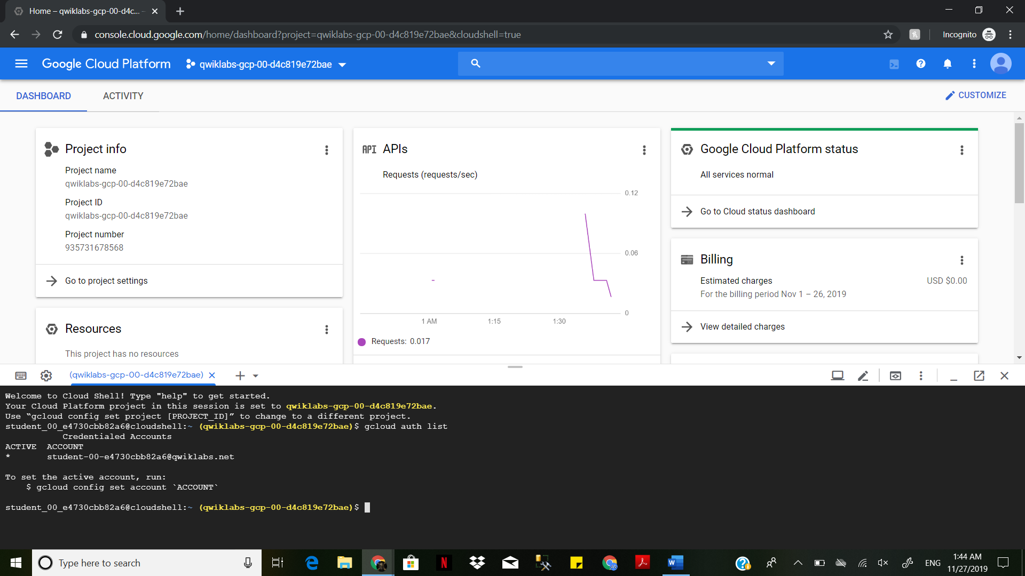

On the Navigation Menu, Click on Storage-> Browser

Create New Bucket and Name it select Region and -> select us-central1(iowa) on drop down menu

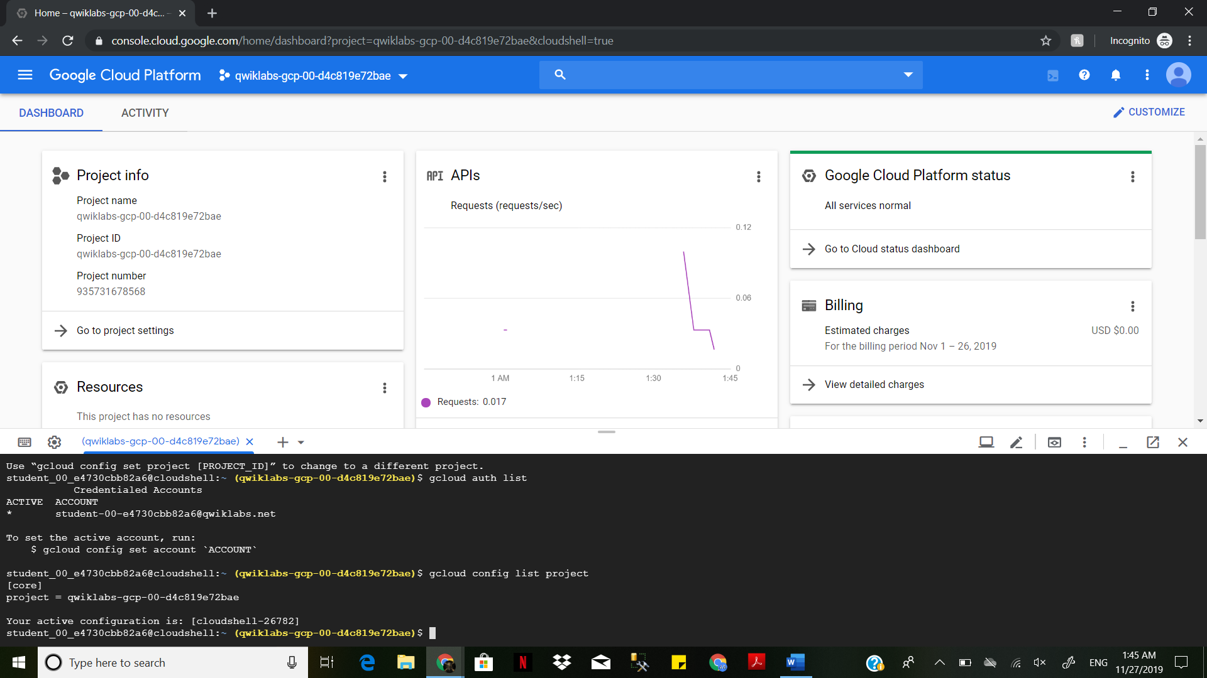

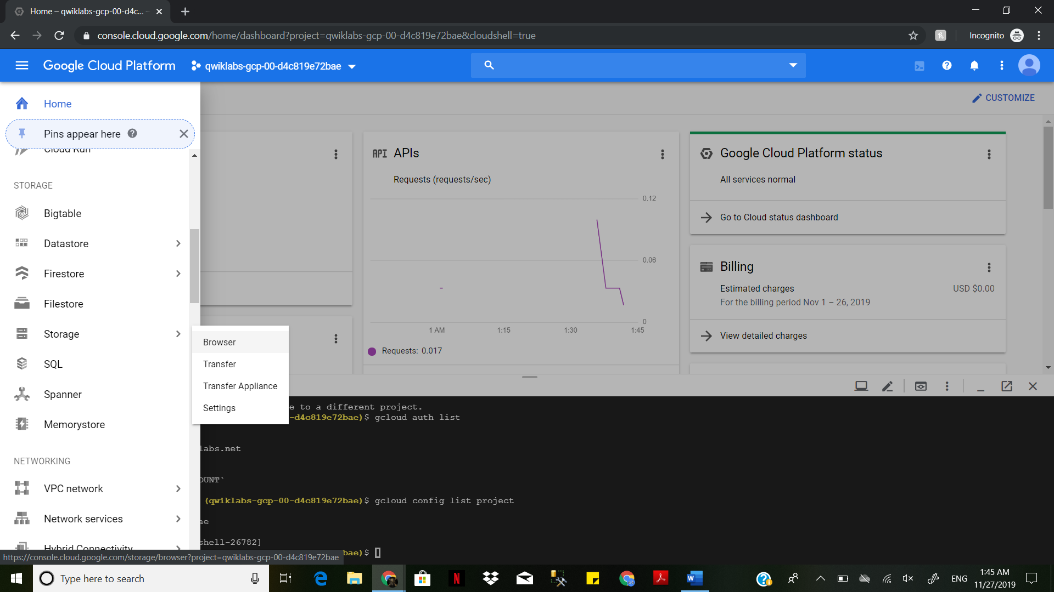

Then click **Create Bucket**. Give it a [unique name](https://cloud.google.com/storage/docs/naming) and the set the **Default storage class** to **regional** and make sure that the location is set to **us-central1**. Then click **Create**.

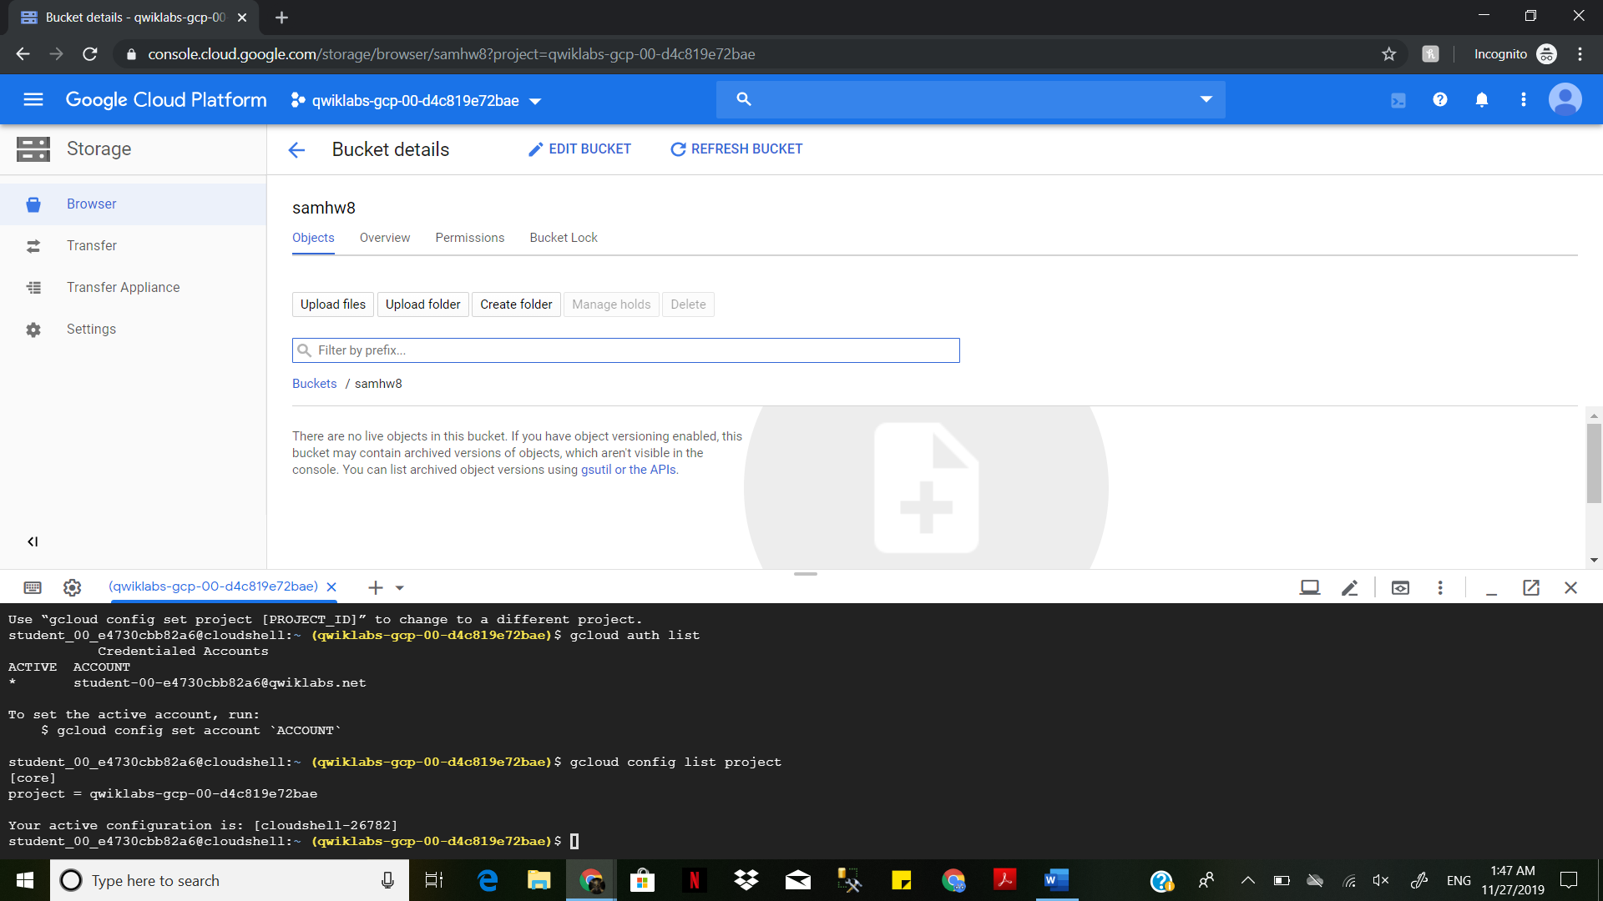

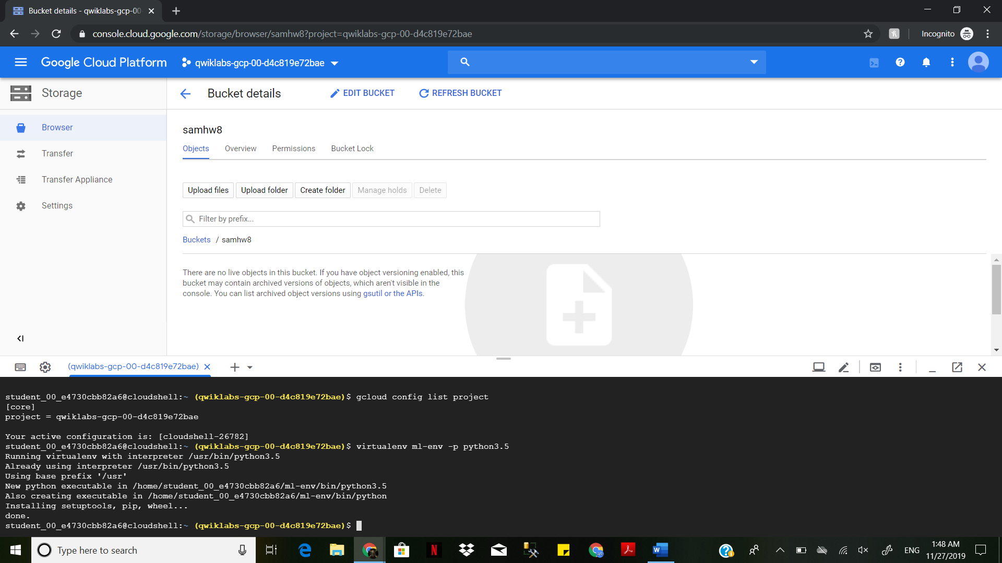

$ virtualenv ml-env -p python3.5

Install Scikit-learn in virtualenv -> $ pip install google-api-python-client==1.6.2

$ pip install scikit-learn==0.19.1

$ pip install pandas==0.22.0

$ pip install scipy==1.0.0

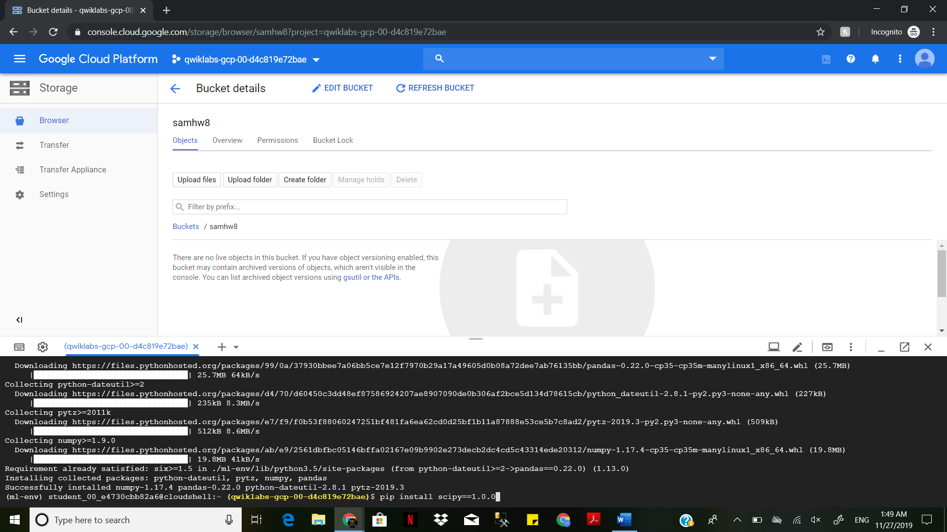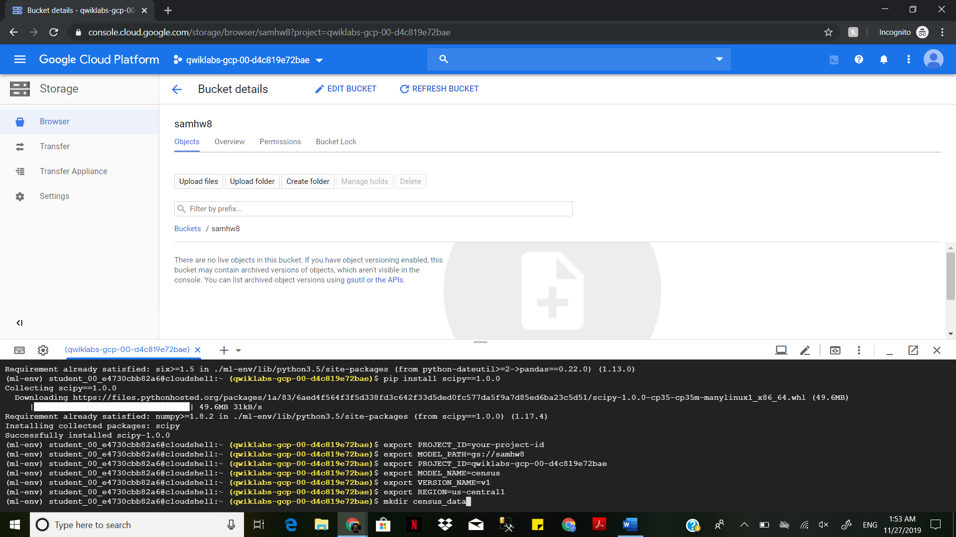

$ mkdir census_data

Download the data -> $curl https://archive.ics.uci.edu/ml/machine-learning-databases/adult/adult.data --output census_data/adult.data

$curl https://archive.ics.uci.edu/ml/machine-learning-databases/adult/adult.test --output census_data/adult.test

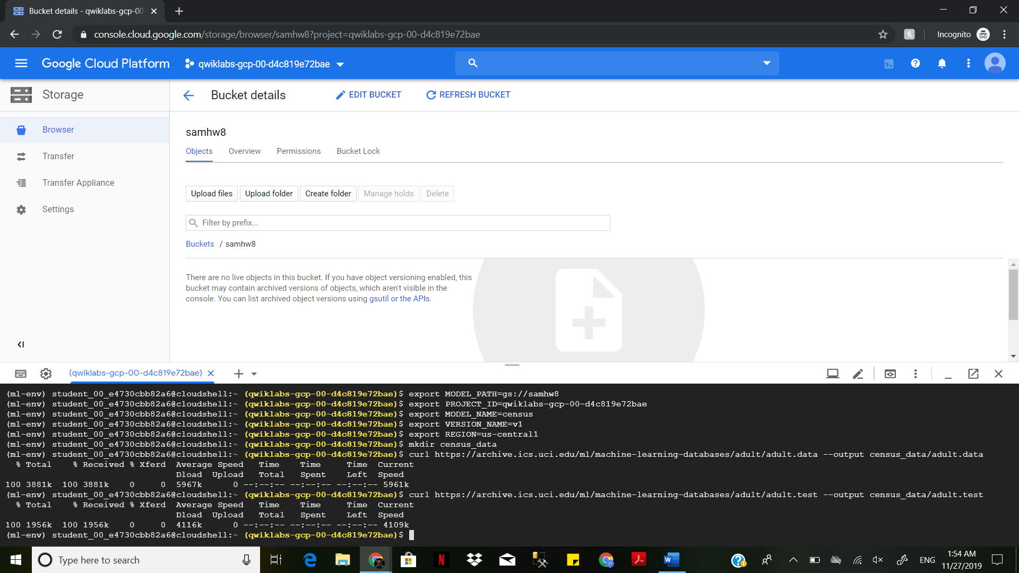

Launch the Google Cloud Shell code editor by clicking pencil icon on top right of the shell

Create a new file -> File-> New File-> < Name the file with appropriate file type> (Ex.train.py)

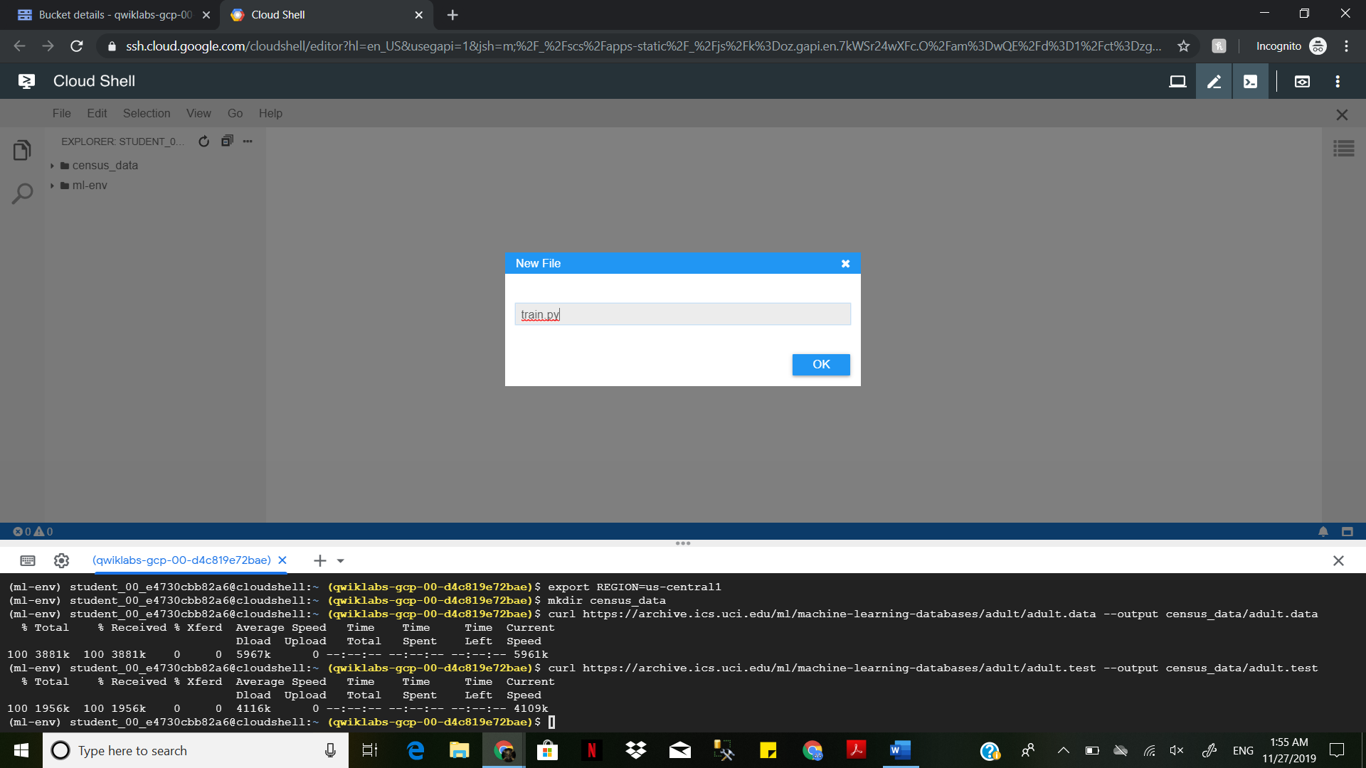

Copy and paste the following in the file created to set up the imports

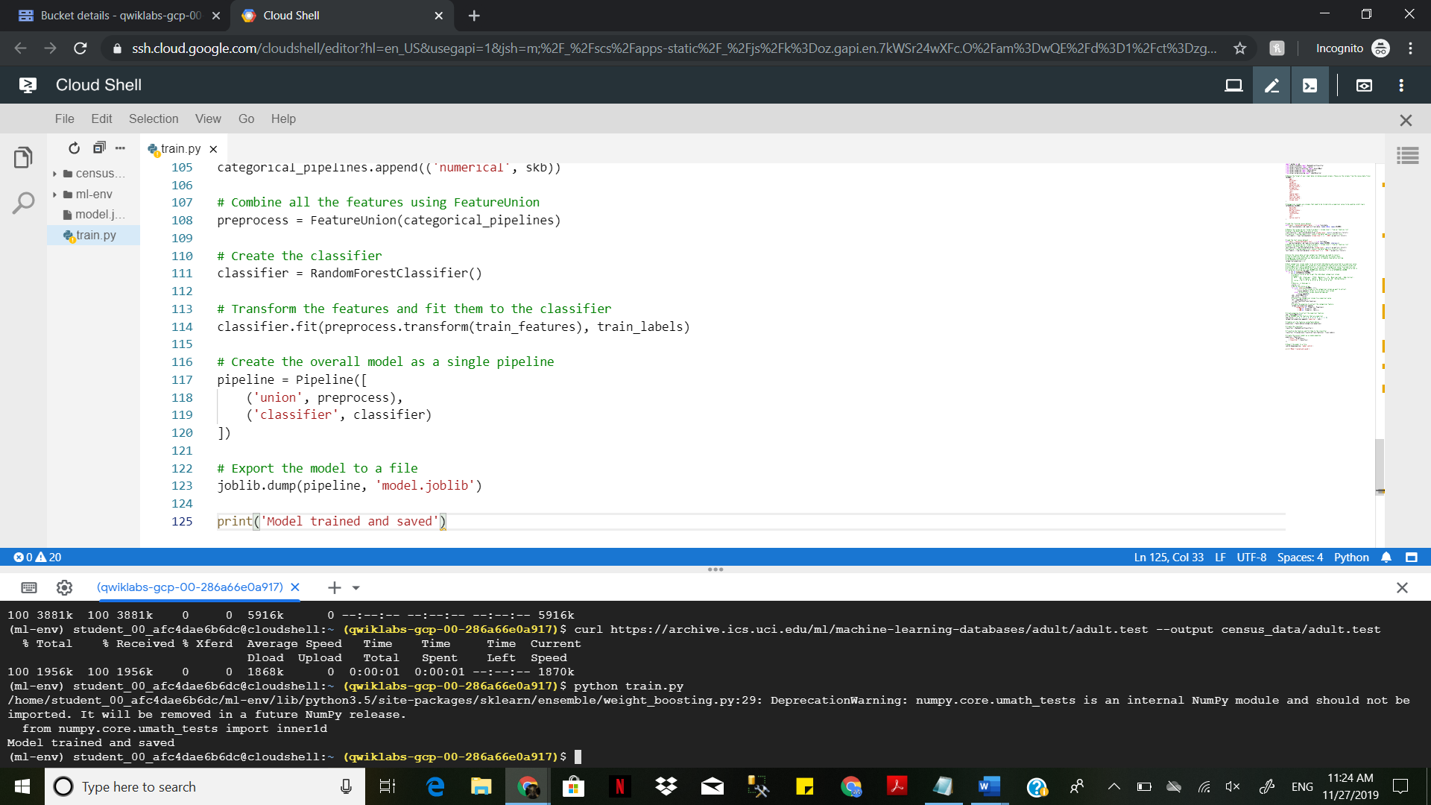

Define the format to the input &&& load the load &&& convert the categorical columns to numerical

values &&& Create and save the classifier to the file. Copy and paste to the file created

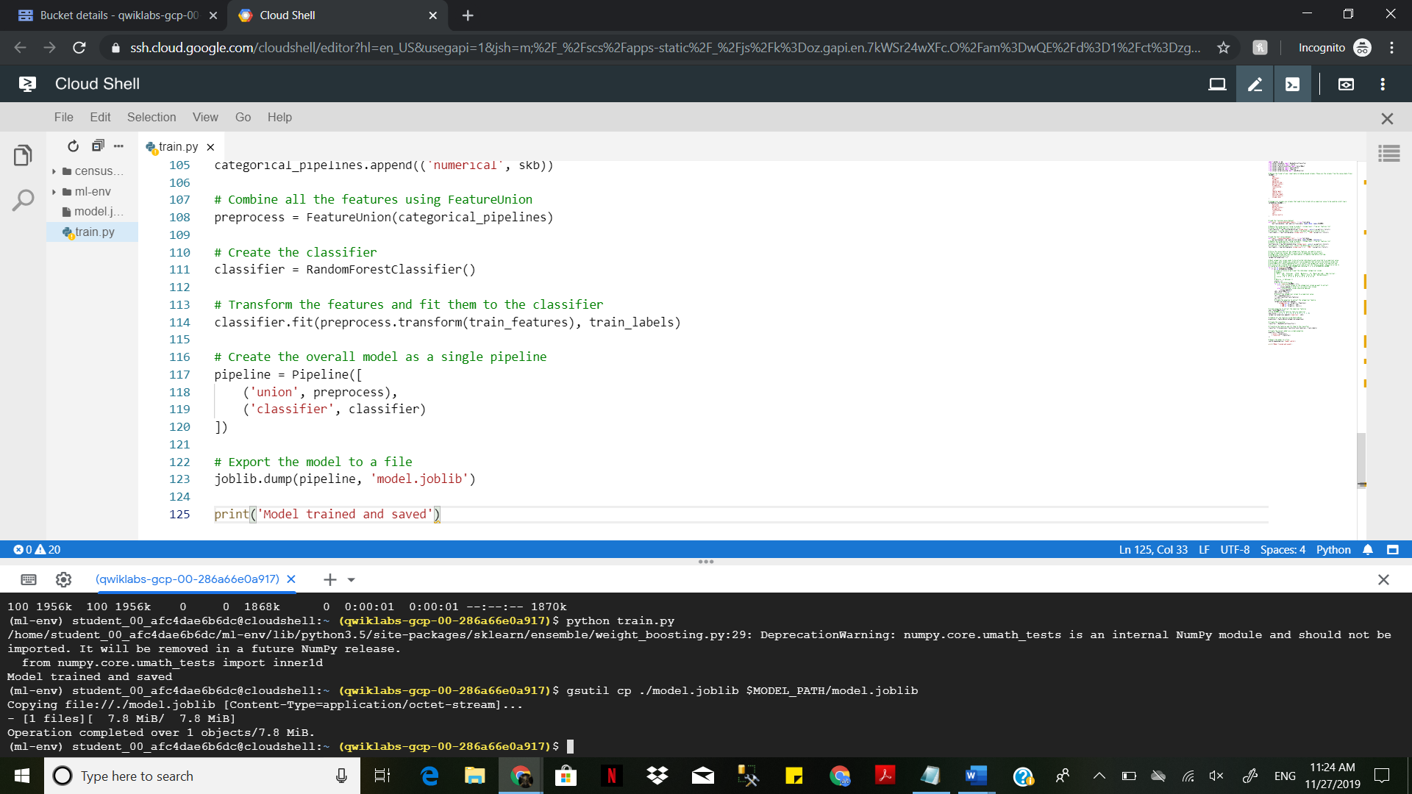

Run the python file -> python train.py

Upload the saved model -> $ gsutil cp ./model.joblib

$ MODEL_PATH/model.joblib

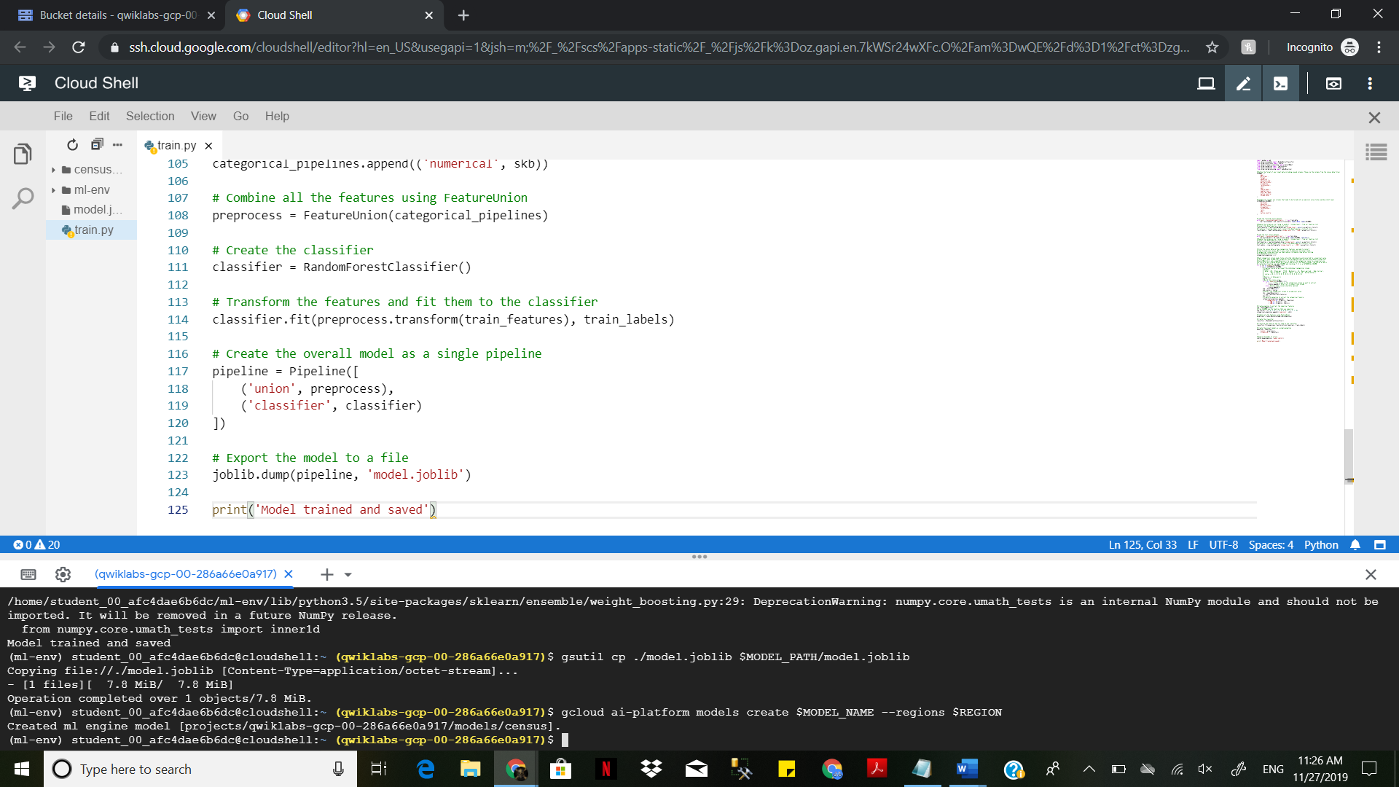

gcloud beta ai-platform versions create $VERSION_NAME \

--model $MODEL_NAME \

--origin $MODEL_PATH \

--runtime-version="1.4" \

--framework="SCIKIT_LEARN" \

--python-version="3.5"

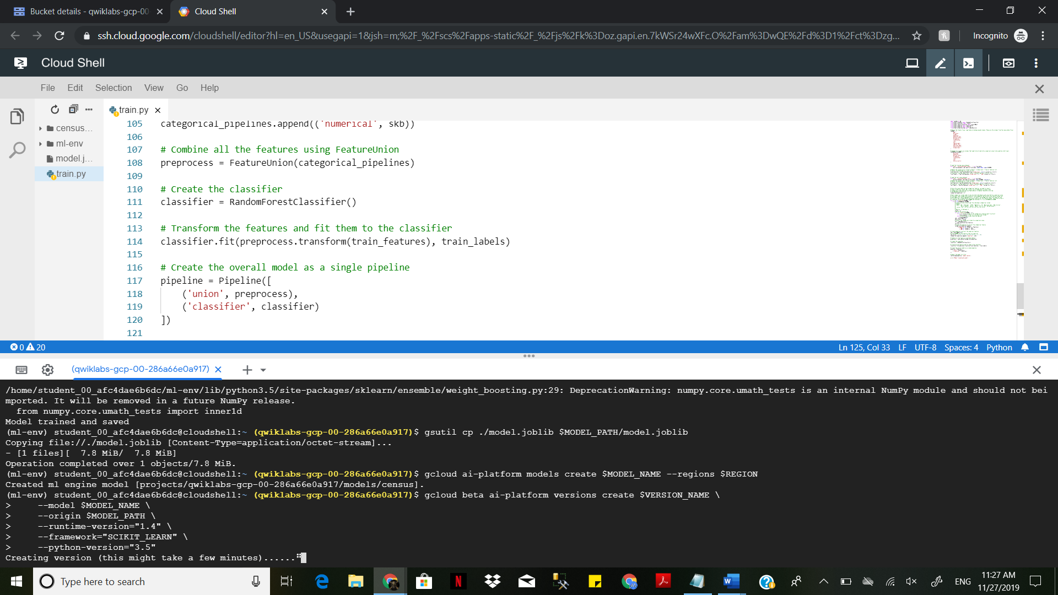

Confirm your model deployment -> $ gcloud ai-platform versions list --model $MODEL_NAME

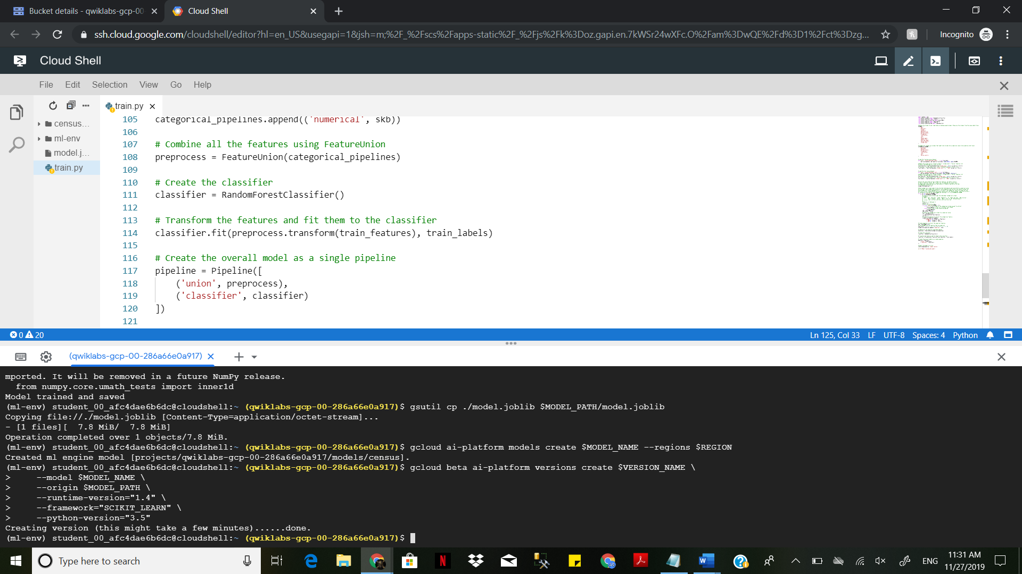

Create a file on editor -> File -> new File-> <Name the file> ( test.py)

Define the format of the column &&& And load the test dataset &&& Concert the test data to numerical values &&& Setup he Google API client to make prediction request

Copy and paste the following to the file created(test.py)

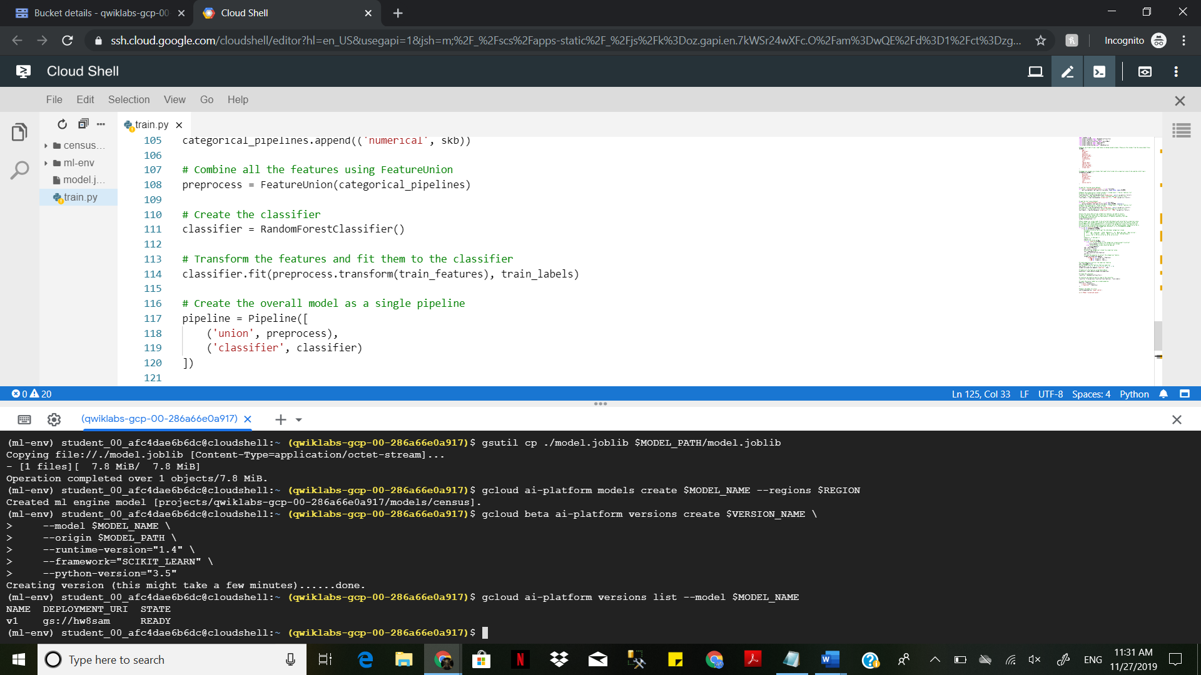

Run the python file on cloud shell -> $ python test.py

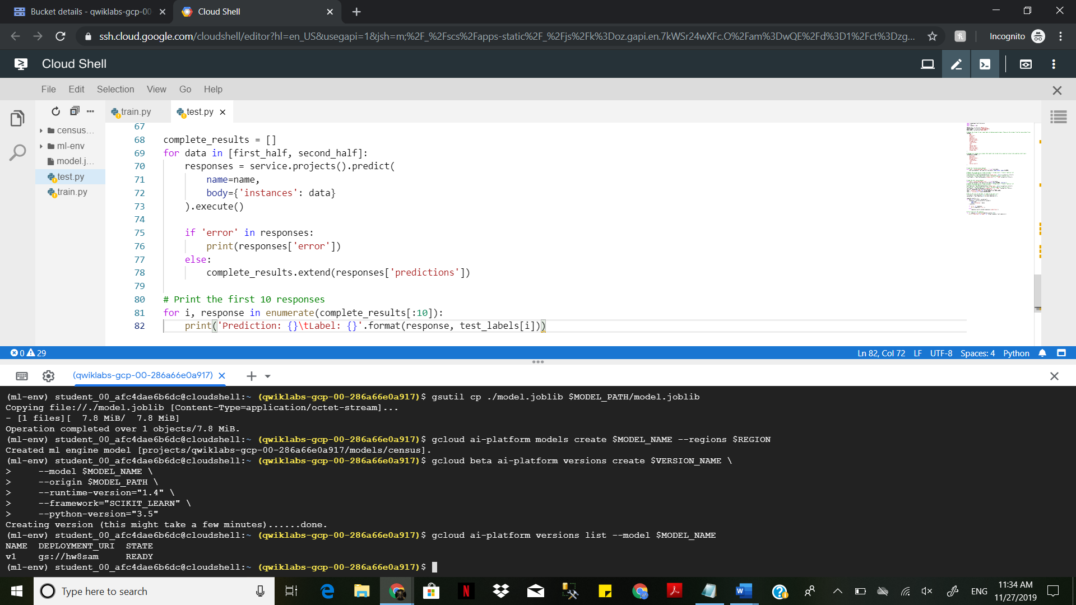

You will be able to see the output making predictions for the test data

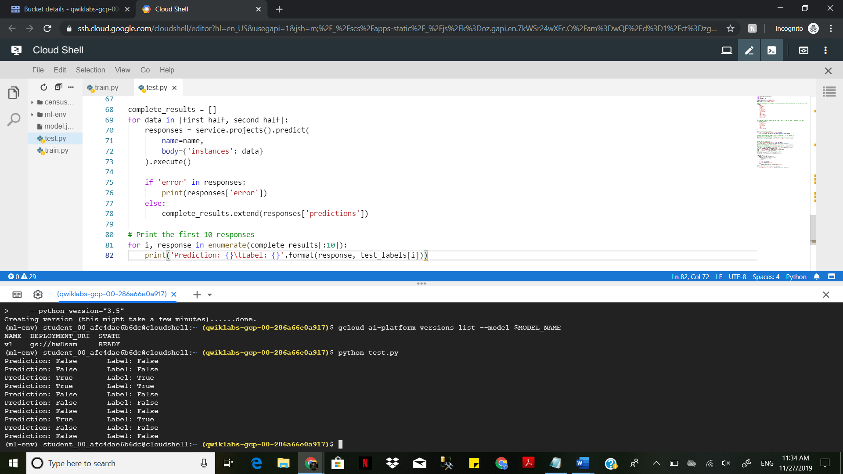

Prediction: False Label:

False Prediction: False Label:

False Prediction: True Label:

True Prediction: True Label: True